6089-103

CMS APOLLO COMMAND MODULE W/ VU7P AND KU15P

HARDWARE MANUAL

Contents

Introduction 3

To Do: 3

Revision History: 4

Version 1.1.1 4

Front Panel LEDs 5

Front Panel Switches 6

Front Panel Connectors 7

KU15P Fiber Connectors 8

On-Board JTAG Jumpers 9

On-Board LEGACY TTC Jumpers 10

On-Board EEPROM WRITE-PROTECT Jumper 11

On-Board Switches 12

New Board Setup 13

1) Install 4 2-mm jumpers on each of the 6 front panel I2C test connectors. 13

2) Attach splice plates 13

3) Install 3 sets of 50-mil jumpers to configure the JTAG chain. 13

4) Power the board, load initial MCU code, and verify voltages. 14

5) Install J9, J10, and J11, the legacy clock routing jumpers 14

6) Clip pin #6 from the TM4C UART connector 15

7) Install cover mounting hardware 15

8) Mount FPGA heatsink backing plates 17

9) Install FireFly heatsink standoffs 18

10) Install LGA80D heatsink standoffs 18

11) Mount FPGA heatsinks 19

12) Prepare and attach the front panel 20

13) Label the front panel MTP connector blocks 21

14) Install FireFly modules 22

15) Attach the LGA80D heatsink 25

16) Route the KU15P FireFly cables 26

17) Route the VU7P FireFly cables 30

17) Mate the CM to the SM 34

18) Attach the covers 34

ADDING AN IND045 M3V3 DC-DC CONVERTER 35

DRIVING I2C SLAVES FROM THE AARDVARK HOST ADAPTER 36

OBSERVING I2C MASTERS WITH THE AARDVARK HOST ADAPTER 40

HISTORY LOG 42

S/N 001 42

S/N 002 42

S/N 003 43

GENERAL HISTORY 43

S/N 004 43

S/N 005 44

S/N 006 44

S/N 007 45

S/N 008 45

S/N 009 46

S/N 010 46

# Introduction

This manual can be found in the Windows directory:

\\samba\accuser\cesrdaq\hardware\CMS_Trigger\6089-103_ATCA_mezz\GitHub\CU_PCB_6089-103\Docs

under the file name:

6089-103_Hardware_Manual.docx

This manual will be updated routinely. Old versions will be saved in the same area.

# To Do:

1.

# Revision History:

## Version 1.1.1

1. Initial version

# Front Panel LEDs

There are 7 LEDs on the front panel. Starting at the top of the board near the JTAG connector, the LED functions are:

1) K DONE (GREEN) – The KU15P FPGA has successfully loaded a configuration file, either from the on-board EEPROM or by way of the JTAG chain. This LED is driven by the DONE_0 pin on the KU15P. (SH 5.04)

2) K RGB (RGB) – This is an uncommitted LED that is driven by three signal lines from the KU15P. The firmware design determines the meaning of the display. (SH 2.11)

3) PWR OK (GREEN) – This LED is driven by the BLADE_POWER_OK signal from the TM4C controller. It will be activated when the TM4C has finished turning on all FPGA power supplies and they are all good. Since this is a GPIO pin on the TM4C, the programmer can use flashing to indicate a problem. (SH 2.11)

4) TM4C ACT (GREEN) – This LED is driven by the TM4C_ACTIVE signal. It will be asserted when both the 3.3v and 1.8v management supplies are good, the BLADE_POWER_EN signal from the service blade is high, and the TM4C RESET switch is not activated. (SH 2.11)

5) TM4C RGB (RGB) – This is an uncommitted LED that is driven by three signal lines from the TM4C. The program determines the meaning of the display. (SH 2.11)

6) V DONE (GREEN) – The VU7P FPGA has successfully loaded a configuration file, either from the on-board EEPROM or by way of the JTAG chain. This LED is driven by the DONE_0 pin on the VU7P. (SH 5.04)

7) V RGB (RGB) – This is an uncommitted LED that is driven by three signal lines from the VU7P. The firmware design determines the meaning of the display. (SH 2.11)

# Front Panel Switches

There are 3 switches on the front panel. Starting at the top of the board near the JTAG connector, the switch functions are:

1) K PROG – The KU15P FPGA will try to reload a configuration file from the on-board EEPROM. This switch is not needed when the reload is commanded by the TM4C, nor when the FPGA is being configured by way of the JTAG chain (SH 5.04)

2) TM4C RESET – The TM4C will go through a power-up reset sequence. All switched power supplies will first be disabled before being re-enabled in the proper sequence.

3) V PROG – The VU7P FPGA will try to reload a configuration file from the on-board EEPROM. This switch is not needed when the reload is commanded by the TM4C, nor when the FPGA is being configured by way of the JTAG chain (SH 6.04)

# Front Panel Connectors

There are 9 connectors on the front panel. Starting at the top of the board near the JTAG connector, the connector functions are:

1) JTAG (SH 2.04):

2) TM4C I2C (SH 4.01):

3) K OPTICS I2C (SH 4.01):

4) FPGA I2C (SH 4.01):

5) PWR I2C (SH 4.01):

6) AMC13 CLK IN (SH 2.08):

7) TM4C UART (SH 2.05):

8) CLOCK I2C (SH 4.01):

9) V OPTICS I2C (SH 4.01):

# KU15P Fiber Connectors

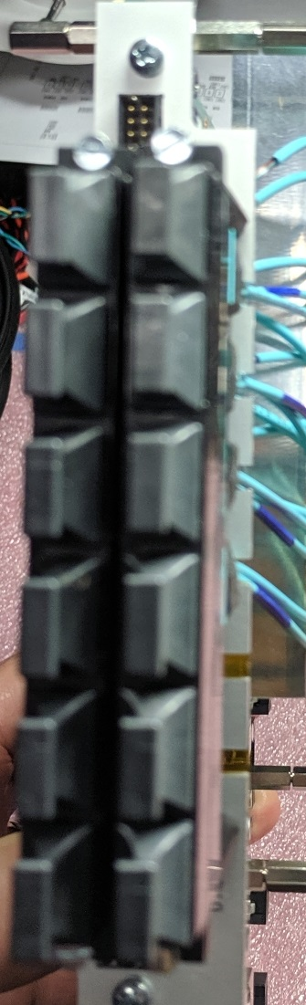

GTY Quad R (133)

FF x4 25 Gbps (U24)

GTY Quad P (131)

FF x4 25 Gbps (U22)

GTY Quad Q (132)

FF x4 25 Gbps (U23)

GTY Quads L/M/N (127/128/129)

FF X12 14 Gbps (U20/U21)

GTH Quads B/C/D (225/226/227)

FF X12 14 Gbps (U104/U105)

GTH Quads H/I/J (231/232/233)

FF X12 14 Gbps (U108/U109)

GTH Quads E/F/G (228/229/230)

FF X12 14 Gbps (U106/U107)

Unused

Unused

# On-Board JTAG Jumpers

There are 4 on-board jumper sites associated with the JTAG chain. They are all located near the front panel, adjacent to the JTAG connector.

1) JTAG NORMAL / BYPASS (SH 2.04): Three pairs of jumpers configure the JTAG chain. The paired jumpers cause the chain to either pass through the associated device (NORMAL) or to jump around the device (BYPASS). Set a pair of jumpers parallel to the front panel to include a device, and perpendicular to bypass a device. Marks on the silkscreen indicate the alignment for NORMAL or BYPASS. The jumpers are labeled V = VU7P, K = KU15P, C = TM4C controller. If a device is not installed, it must be bypassed. The illustration below shows the TM4C as the only device in the chain, with both FPGAs bypassed.

2) JTAG FORCE FRONT PANEL (SH 2.04): The JTAG chain can be driven either from the service module or from the front panel connector. Normally, if no cable is plugged into the front, the chain defaults to being driven by the service module. Plugging in a cable that has pin-13 connected to GND will switch the chain to use signals from the cable. However, if the particular cable does not automatically connect pin-13 to GND, a jumper can be used to force the use of the front panel connector.

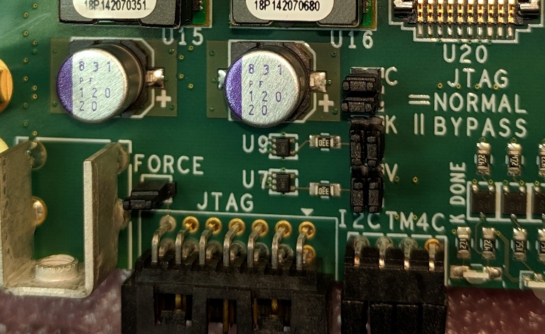

J15 - TM4C Normal

J13 - VU7P Bypassed

J14 - KU15P Bypassed

Front panel JTAG forced

# On-Board LEGACY TTC Jumpers

There are 3 on-board jumper sites associated with the legacy TTC signals. They are all located near the front panel, adjacent to the AMC13 CLK IN SFP connector.

1) CONNECT KU15P or VU7P (SH 2.08): Three pairs of jumpers configure the TTC signals to connect to either the KU15P or the VU7P. Each signal uses 3 pins. The center pin is the signal from or to the legacy TTC electronics. The pin closest to the KU15P connect to the KU15P. The pin closest to the VU7P connects to the VU7P.

Legacy TTC signals can only connect to one FPGA. If both FPGAs need the signals, the FPGA firmware needs to route the signals between the two FPGAs using some of the spare traces (SH 5.07 and 6.07).

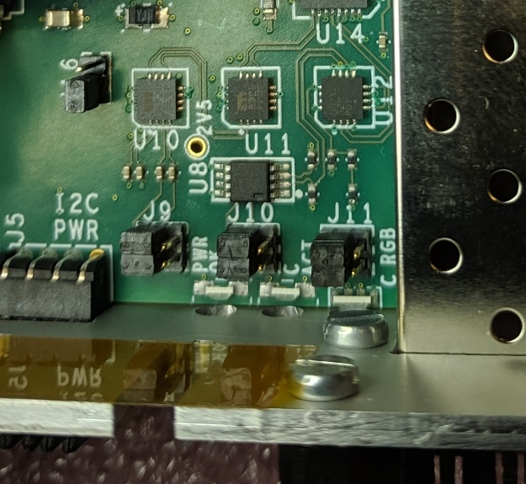

J10 – TTC data to KU15P

J11 – TTS clk/data from KU15P

J9 – TTC clock to KU15P

# On-Board EEPROM WRITE-PROTECT Jumper

There is one on-board jumper that controls the WRITE-PROTECT input of the EEPROM. It is near the front panel, adjacent to the AMC13 CLK IN SFP connector.

1) EEPROM WRITE PROTECT (SH 4.01): This jumper configures the hardware write-protect pin. Pin 1 is closest to the front panel.

a) If no jumper is in place, the hardware write protection is always enabled.

b) If the jumper connects pins 1 and 2, the hardware write protection is always disabled.

c) If the jumper connects pins 2 and 3, the hardware protection is controlled by a GPIO pin on the TM4C controller.

Refer to the data sheet for details about connecting an external high voltage to reset the software write protect fuse.



J16 – EEPROM always writable

# On-Board Switches

There are 2 on-board DIP switches.

1) JTAG (SH 2.04):

# New Board Setup

These steps need to be followed for all new boards.

## 1) Install 4 2-mm jumpers on each of the 6 front panel I2C test connectors.

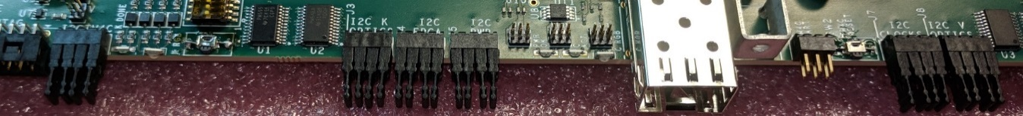

Set of 4 jumpers

## 2) Attach splice plates

at each end, using 3 M3x4 pan-head screws. Do not use M3x6 screws, as they are too long and can interfere with the VU7P heatsink. Do not use washers, since the height of the screw head plus washer is too much for the bottom side of the board.

Install 3 M3x6 pan-head screws in the holes that will be used to mate to the SM (service module). This will make sure that screws are available when final mating takes place.

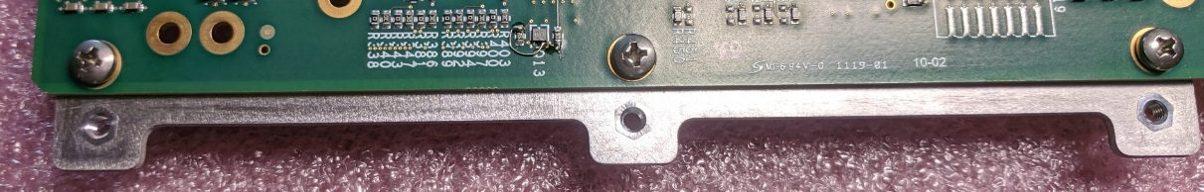

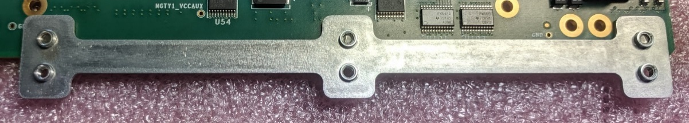

Add a label about using M3x4 screws on the CM. Longer screws interfere with the FPGA heatsink.

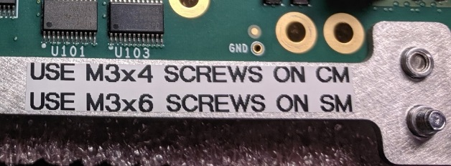

## 3) Install 3 sets of 50-mil jumpers to configure the JTAG chain.

For the initial operation, the TM4C “C” should be set for NORMAL, and the KU15P “K” and VU7P “V” should be set for BYPASS. The silkscreen legend indicates how NORMAL has the jumpers parallel to the front panel, while BYPASS has them perpendicular to the front panel.

Use jumpers made from 4-pin connectors. We have found that standard 50 mil jumpers tend to have their connections deformed after a few uses, and stop making contact.

Omit the 50-mil jumper on the pins labeled FORCE. This jumper would force the JTAG chain to use only the front panel connector. However, the programmer cables will connect the JTAG connector pin #13 to GND. With no cable, the SM will control the JTAG chain.

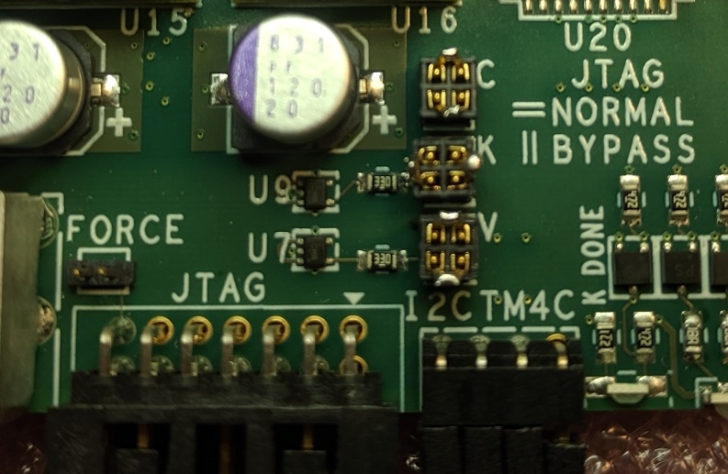

TM4C NORMAL

KU15P BYPASS

VU7P NORMAL

FORCE FRONT PANEL JTAG

## 4) Power the board, load initial MCU code, and verify voltages.

Use the DIP switch to enable power for FPGAs that are on the board and disable power for unpopulated FPGA sites.

Use the Segger programmer and “J-Link Commander” to (re)program the MCU.

1. Use the Segger JTAG programmer to load a version of the code that has the power sequencer.
2. Connect the programmer to the JTAG header.
3. Start the JlinkCommander “JLink.exe” program.
4. Verify that the TM4C disable jumper has been removed from connector P1.
5. Apply power.
6. Issue the command: usb
7. Issue the command: connect
   1. Device: TM4C1290NCPDT
   2. Interface: JTAG
   3. Position: 0,0 (unless the KU15P is also in the chain)
   4. Speed: 1000 kHz
8. The programmer should issue a multi-line response, starting with: “Device “TM4C1290NCPDT” selected.
9. Put the binary to be loaded in a director with a short path name, like “c:/temp”. Program the TM4C by issuing the command: loadfile c:/temp/project2_v0_9.bin
10. Start the program by cycling power. The “PWR_OK” LED should turn on. There should be a way to do this without cycling power.

5) Install J9, J10, and J11, the legacy clock routing jumpers

Use the positions to send the signals to the KU15P. However, if the board does not have a KU15P, or if the board requires using the VU7P for the legacy clock, insert them in the position to send the signals to the VU7P.

Install J16, the EEPROM “write protect” jumper, in the “always writeable” position.

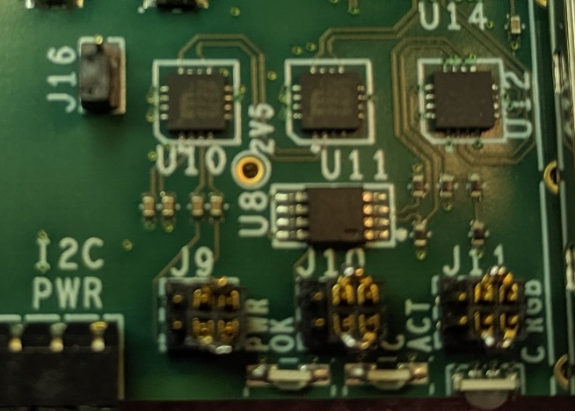

LEGACY CLOCK TO VU7P

EEPROM WRITEABLE

## 6) Clip pin #6 from the TM4C UART connector

This will “key” the header so that the mating connector cannot be inserted in the wrong orientation.

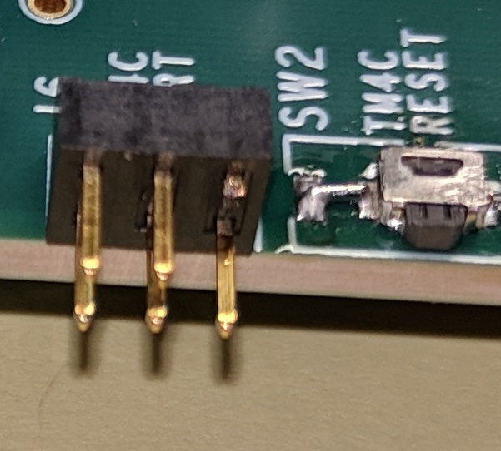

Cut pin #6 (upper right)

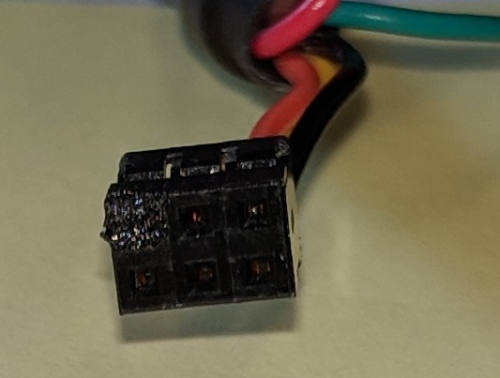

Pin #6 is obstructed

## 7) Install cover mounting hardware

Apply Mylar tape to the bottom (flat) side of two thick and two thin cover attachment blocks. The thick blocks are about 4 mm thick. Thin blocks are about 3 mm thick. Cut a hole in the tape over the counter-bored hole.

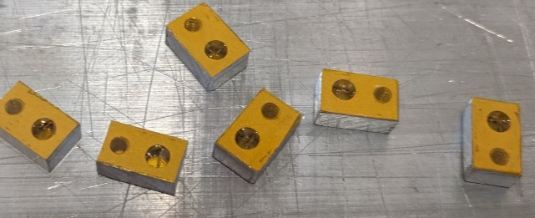

Note: Some of the blocks are wider than others. Make sure that nothing is being shorted on the bottom side of the board.

Put an M2.5 lockwasher on an M2.5x12 cheese head screw. Insert the screw into the counter-bored holes on the cover attachment blocks.

For the two mounting holes farthest from the front panel, use thick blocks. For the two mounting holes nearest the front panel, use thin blocks.

Install 20 mm long M2.5 threaded standoffs in three mounting holes as shown on the photo. Insert the screw into the appropriate holes from the bottom. On the top side, use three M2.5 flat washers and the M2.5 standoff.

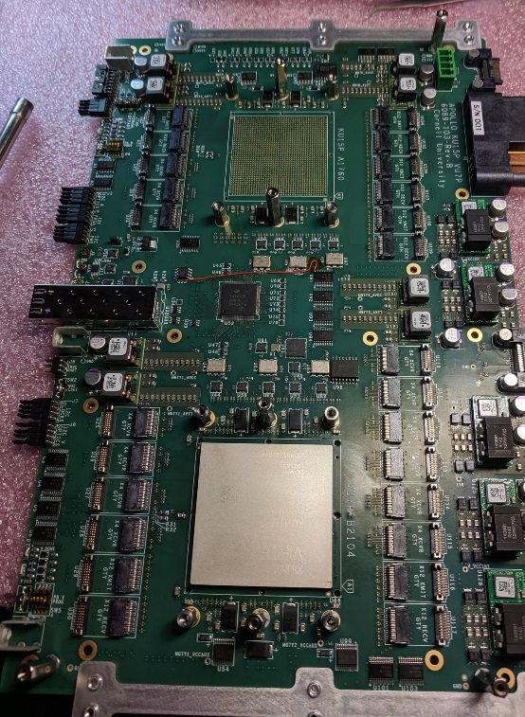

No standoff here

20 mm STANDOFFS

Cover block with nut here

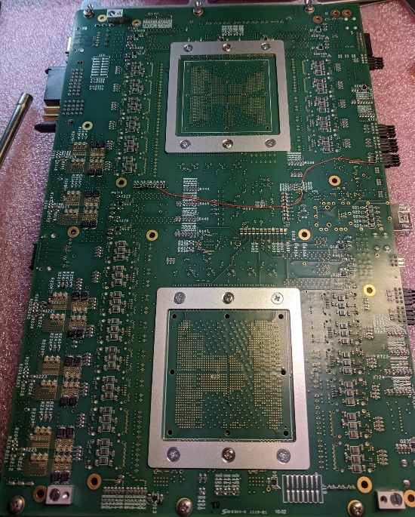

Cover blocks assembled to 20 mm standoffs. Note which way they are oriented.

Install a cover block without the standoff in the last corner mounting hole as shown on the photo. This is the corner where the SM’s “front panel board” prevents use of a standoff. Put an M2.5 lockwasher on an M2.5x12 cheese head screw. Insert the screw into the countersunk hole on the cover attachment block. Now insert the screw into the appropriate hole from the bottom. On the top side, use an M2.5 flat washer and an M2.5 nut.

Align the cover blocks and tighten the standoffs or the nut.

## 8) Mount FPGA heatsink backing plates

Apply Mylar tape to the back side of two backing plates. The back side is the one opposite the countersunk holes. The tape will overlap at the corners. Poke holes in the tape at each of 6 screw holes. Install both backing plates, even if only one FPGA is mounted.

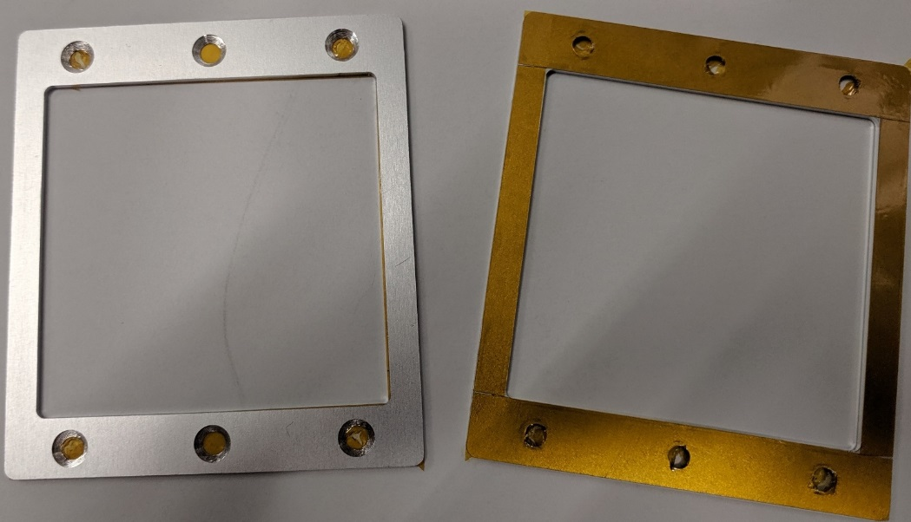

Attach the backing plate to the bottom side of the board, using 4 M3x6 FH screws, 4 M3 lockwashers, and 4 10 mm long M3 threaded standoffs in the corners of the backing plate. The lockwasher and standoff go on the top side of the board. Tighten.

Install 20 mm long M2.5 threaded standoffs in the unused center holes. Insert an M2.5x8 FH or oval head screw from the bottom. On the top side, use two M2.5 flat washers, an M2.5 lockwasher, and the M2.5 standoff. Just make them finger-tight for now. Slip a heatsink over the 6 standoffs. Center and tighten the 20 mm standoffs, making sure the heatsink does not bind on any standoffs.

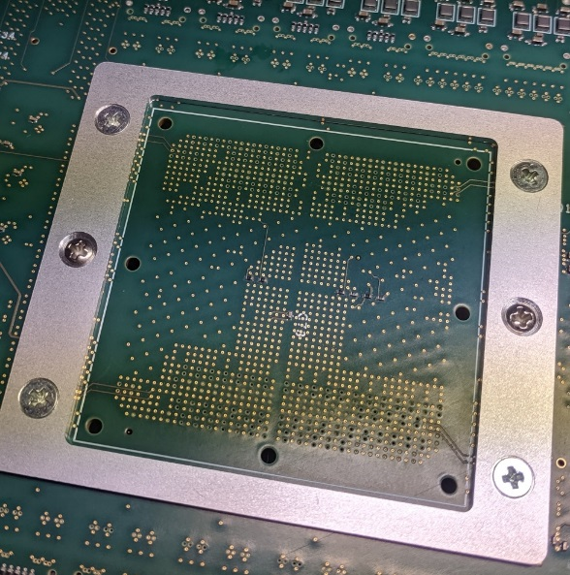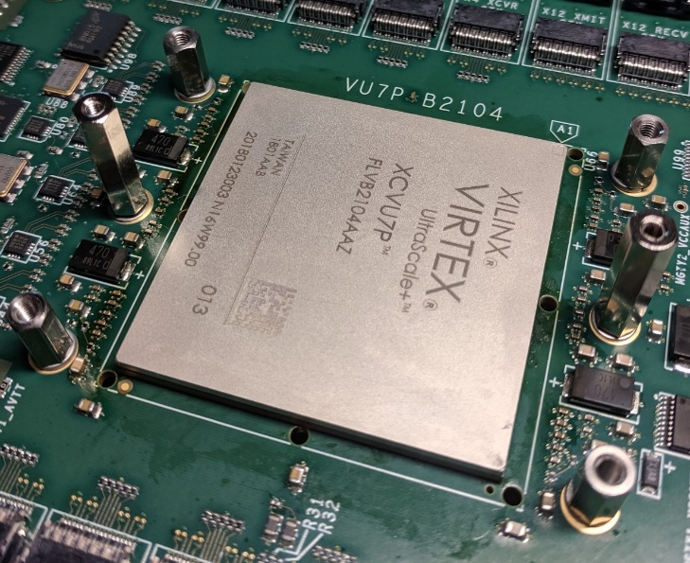

## 9) Install FireFly heatsink standoffs

Install 6 8 mm long M2.5 threaded standoffs on the board, using 6 M2.5x6 screws, 6 M2.5 lock washers, and 6 M2.5 flat washers. The lock washers should be on the bottom side of the board, under the screws. The flat washers should be on the top side of the board, under the standoffs. The standoffs go in the holes that are in-line with the FireFly sockets. Two of the six standoffs are shown in the photo.

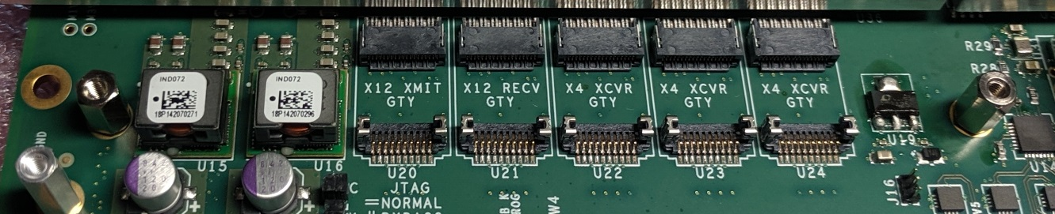

## 10) Install LGA80D heatsink standoffs

Install 3 12 mm long M2.5 threaded standoffs on the board, using 3 M2.5x6 screws, 3 M2.5x6 flat washers, and 3 M2.5 lock washers. The flat washers and lock washers should be on the top side of the board, under the standoffs. The standoffs go in the holes that are in-line with the LGA80D power modules. Two of the three standoffs are shown in the photo.

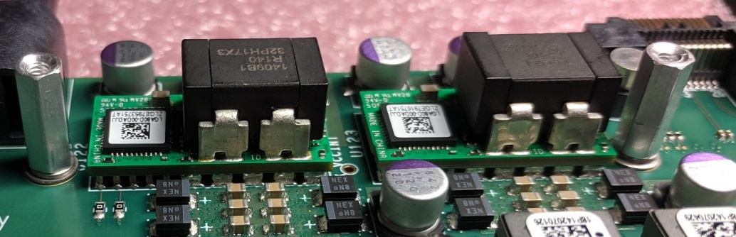

## 11) Mount FPGA heatsinks

Cut square pieces of 20 mil thick heatsink foam for each FPGA that is installed. One is 50 mm x 50 mm (2” x 2”) for the big chip, and the other is 45 mm x 45 mm (1.75” x 1.75”) for the small chip. Peel the cover from one side of the foam and place it on the FPGA. The pieces are slightly larger than the chips and should overlap on all 4 sides. Lightly press it in place and carefully remove the remaining cover. Do not let any bumps or bubbles form in the material.

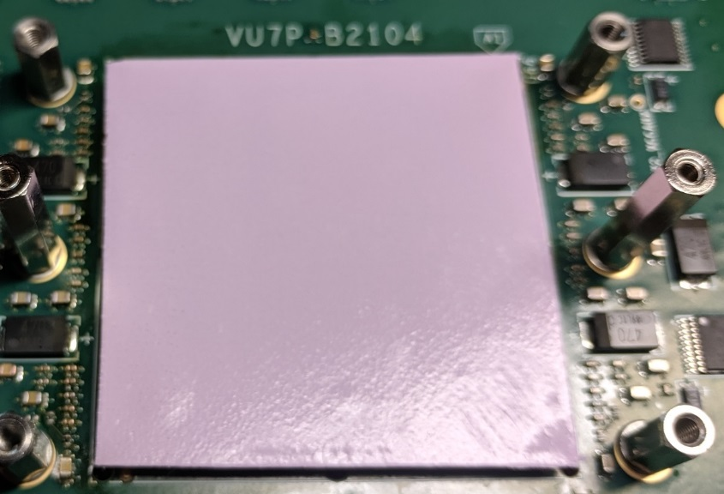

Heatsinks come in two lengths, 150 mm and 125 mm. If the board only has one FPGA, use the long ones. If the board has two FPGAs, use the long one on the VU7P and the short one on the KU15P. Place an appropriate heatsink over the FPGA. It gets oriented such that it does not hang over the edge of the board.

Attach the heatsink, using 4 springs, 4 M3x6 round-head screws, 4 4-40 flat washers (they have a bit larger OD than M3 washers), and 4 M3 lock washers. Drop the springs over the 4 corner standoff, then start the screws about ½ turn. You may need to push the screw down to get the threads to catch. Once all 4 have caught, turn each one a half turn. After all 4 have been turned a half turn, turn each one another half turn. Finish when the top of each screw head is about 2.5 mm below the top of the heatsink.

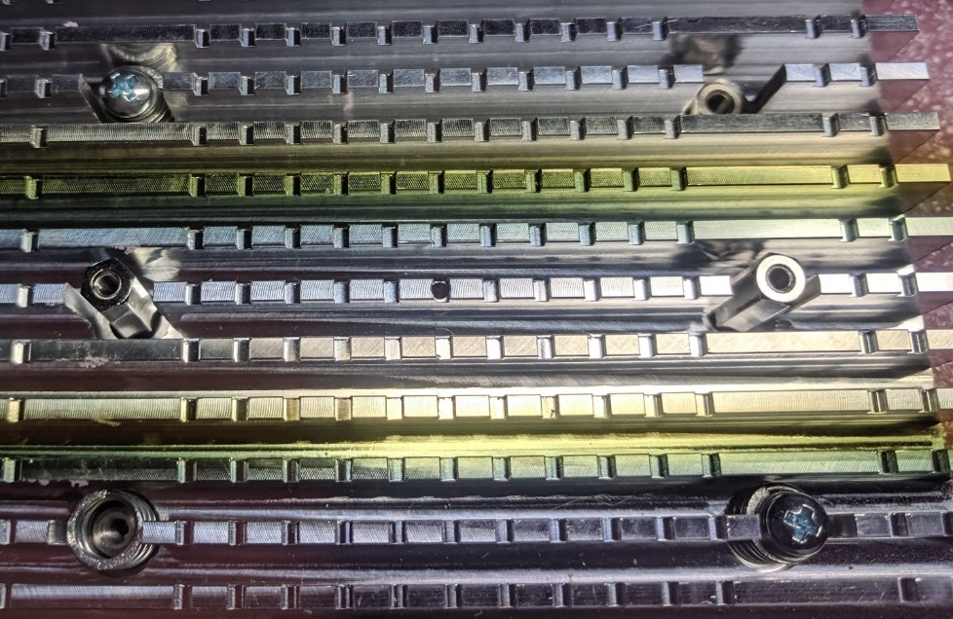

Repeat the process for the other FPGA if necessary.

## 12) Prepare and attach the front panel

If both FPGAs are installed, attach 8 45 mm long M2.5 threaded standoffs to a front panel, using 8 M2.5x6 screws and 8 M2.5 lock washers. The lock washers should be on the face of the panel, under the standoff. Install M2.5x12 screws in the other end of the standoffs, about 3 turns.

If only one FPGA is installed, omit the standoffs for the other and cover the slots from the back with Mylar tape.

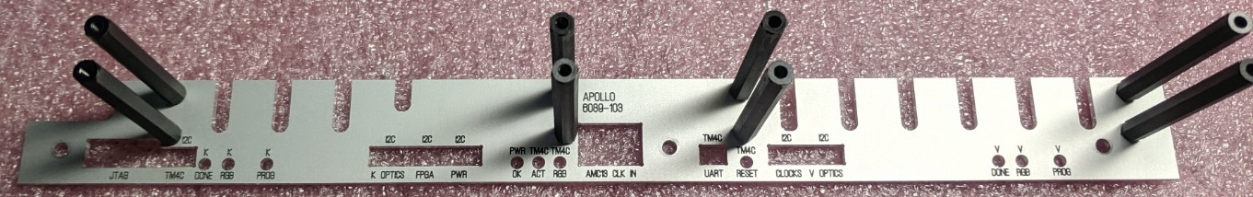

Use 3 M3x6 round head screws to attach the front panel. Slightly squash the springy things on the front of the SFP cage so that the front panel will be removable.

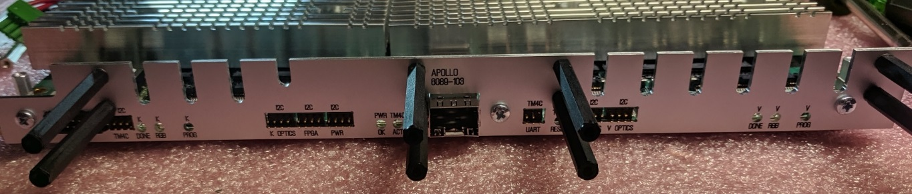

If they are not already in place, install 24 2 mm jumpers on the 6 sets of I2C pins that protrude through the front panel. You may need to loosen the front panel mounting screws in order to fit the jumpers fully over the pins.

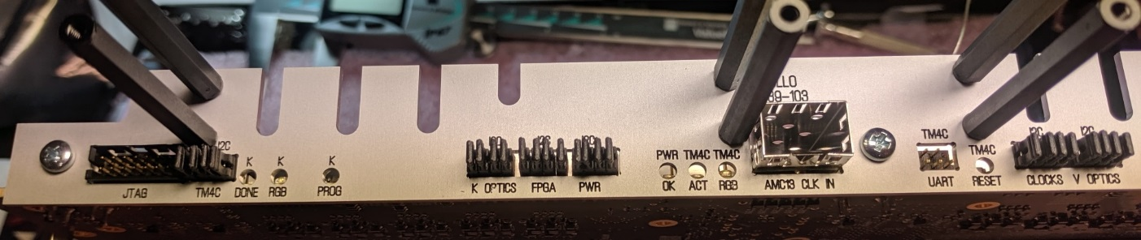

## 13) Label the front panel MTP connector blocks

In the photo, the top left connector block #1 is for the KU15P FireFlys that are mounted to the left as one views the front panel face-on. The labels are on the same side of the connector block as the MTP alignment keys (when the keys are viewed looking face-on at the front panel).

In the photo, the top right connector block #2 is for the KU15P FireFlys that are mounted to the right as one views the front panel face-on. The labels are on the opposite side of the connector block as the MTP alignment keys (when the keys are viewed looking face-on at the front panel).

.

In the photo, the bottom left connector block #3 is for the VU7P FireFlys that are mounted to the left as one views the front panel face-on. The labels are on the same side of the connector block as the MTP alignment keys (when the keys are viewed looking face-on at the front panel).

In the photo, the bottom right connector block #4 is for the VU7P FireFlys that are mounted to the right as one views the front panel face-on. The labels are on the opposite side of the connector block as the MTP alignment keys (when the keys are viewed looking face-on at the front panel).

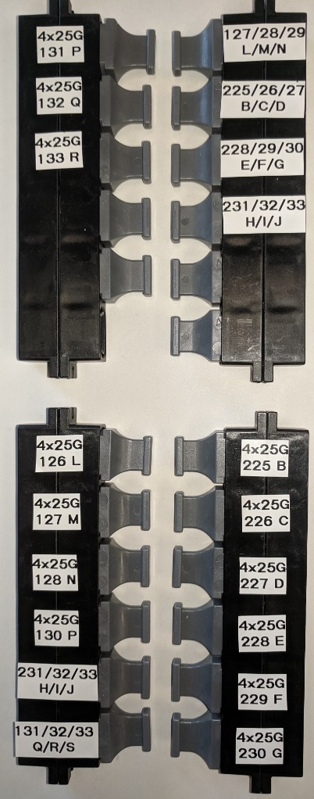

## 14) Install FireFly modules

Each FireFly location on the PCB has 3 labels. One is for the type of FireFly module, one is for the type of Xilinx transceiver block connected to that location, and the third is the connector location reference designator.

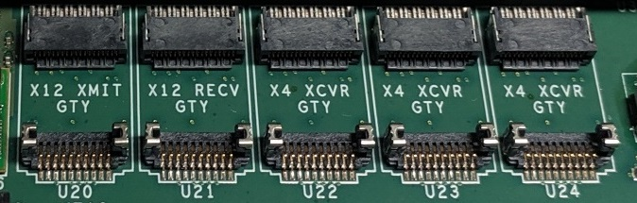

X12 XMIT – The transmitter module of a 12-lane pair, marked “T” on the module

X12 RECV – The receiver module or a 12-lane pair, marked “R” on the module

X4 XCVR – A combined 4-lane transmitter and receiver, marked “TR” on the module

GTH – A transceiver with a 14/16 Gbps limit, depending on the chip speed grade

GTY – A transceiver with a 25/28 Gbps limit, depending on the chip speed grade

Each FireFly module is labeled on the bottom with either a:

“T” - 12-lane transmitter

“R” – 12-lane receiver

“TR” – 4 lane transceiver

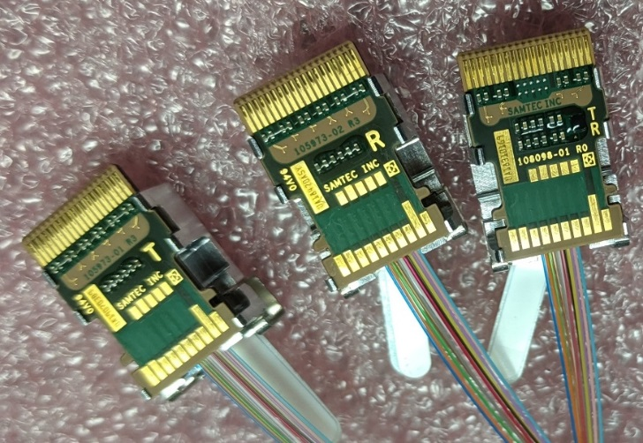

The following table gives all of the details about each FireFly location.

|  |  |  |  |  |  |  |
| --- | --- | --- | --- | --- | --- | --- |
| Reference | FPGA | Quad number | Quad location | Quad type |  |  |
| U20 | KU15P |  | L/M/N | GTY |  |  |
| U21 | KU15P |  | L/M/N | GTY |  |  |
| U22 | KU15P |  | P | GTY |  |  |
| U23 | KU15P |  | Q | GTY |  |  |
| U24 | KU15P |  | R | GTY |  |  |
| U25 | VU7P |  | L | GTY |  |  |
| U26 | VU7P |  | M | GTY |  |  |
| U27 | VU7P |  | N | GTY |  |  |
| U28 | VU7P |  | P | GTY |  |  |
| U29 | VU7P |  | Q/R/S | GTY |  |  |
| U30 | VU7P |  | Q/R/S | GTY |  |  |
| U104 | KU15P |  | B/C/D | GTH |  |  |
| U105 | KU15P |  | B/C/D | GTH |  |  |
| U106 | KU15P |  | E/F/G | GTH |  |  |
| U107 | KU15P |  | E/F/G | GTH |  |  |
| U108 | KU15P |  | H/I/J | GTH |  |  |
| U109 | KU15P |  | H/I/J | GTH |  |  |
| U110 | VU7P |  | B | GTY |  |  |
| U111 | VU7P |  | C | GTY |  |  |
| U112 | VU7P |  | D | GTY |  |  |
| U113 | VU7P |  | E | GTY |  |  |
| U114 | VU7P |  | F | GTY |  |  |
| U115 | VU7P |  | G | GTY |  |  |
| U116 | VU7P |  | H/I/J | GTY |  |  |
| U117 | VU7P |  | H/I/J | GTY |  |  |

Insert the required modules into the connectors. Fan the cables off to the sides. Be sure the two fibers bundles of the transmitter/receiver pairs are not spiraled around each other.

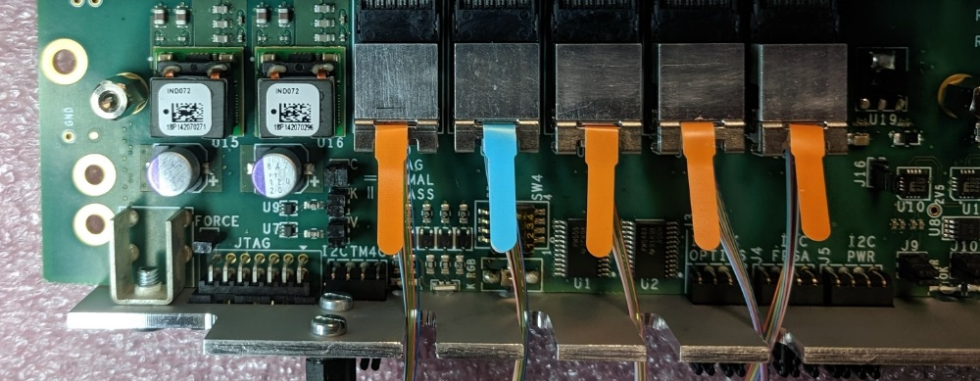

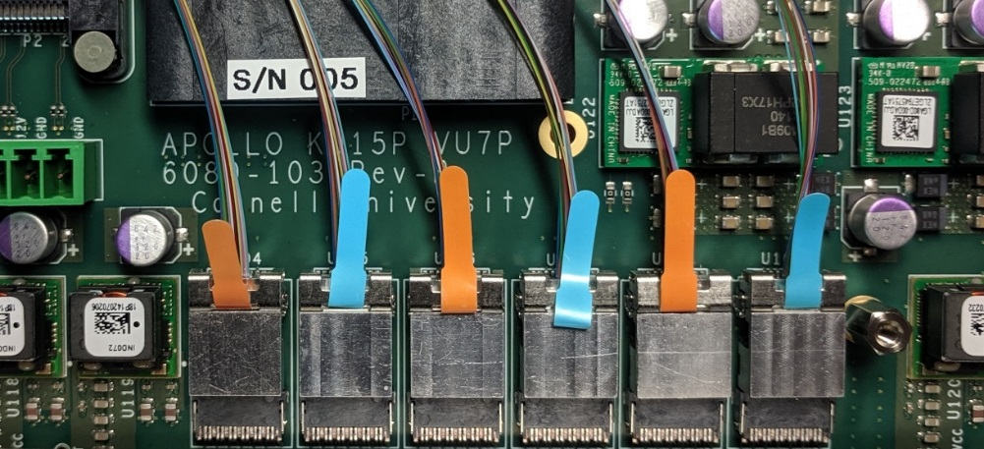

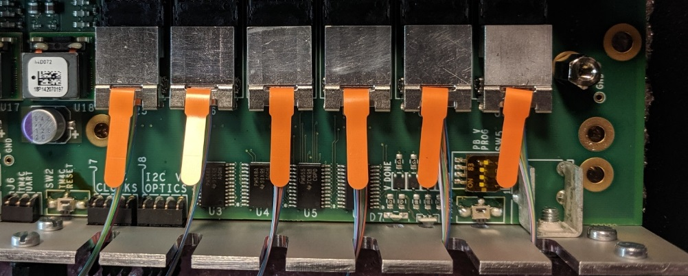

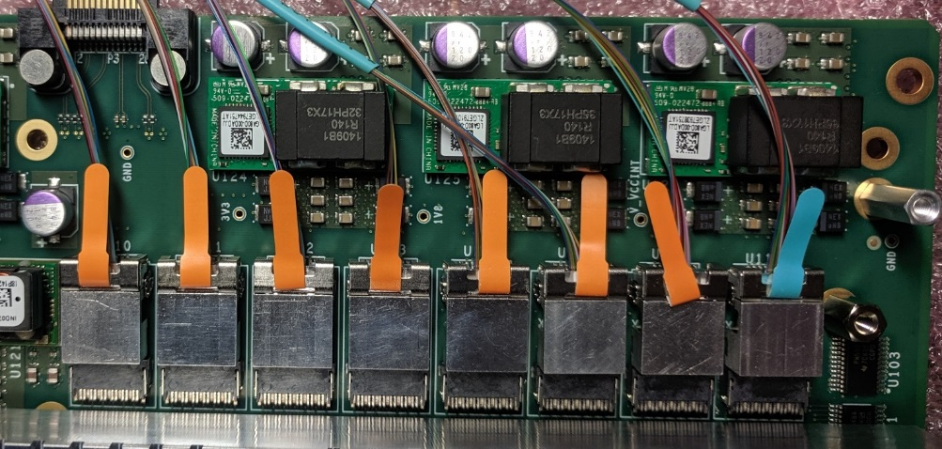

For each bank of FireFly modules, cut one piece of 70 mil thick heatsink foam. The strips are 10 mm (7/16”) wide. The lengths depend on the number of FireFly modules populating a bank.

1 FireFly:

2 FireFlys

3 FireFlys

4 FireFlys: 2”

5 FireFlys: 64 mm (2 1/2”)

6 FireFlys: 80 mm (3 1/8”)

7 FireFlys

8 FireFlys: 105 mm (4 1/8”)

Place the 70 mil thick piece of foam over a bank of FireFlys. Be sure that the foam does not overlap the retaining clips, otherwise it will be too thick. If the foam wants to overlap an adjacent regulator or standoff, trim it after removing the backing cover.

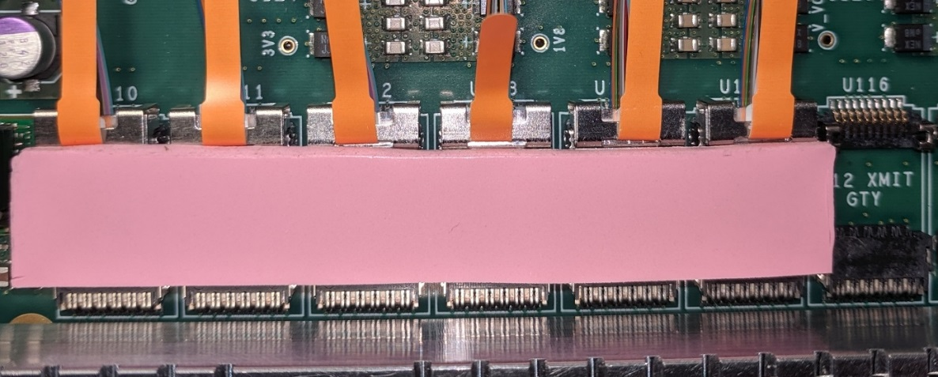

Mount the appropriate front or rear heat sink, using 3 M2.5x6 screws and 3 M2.5 lockwashers. In a staggered fashion, tighten them.

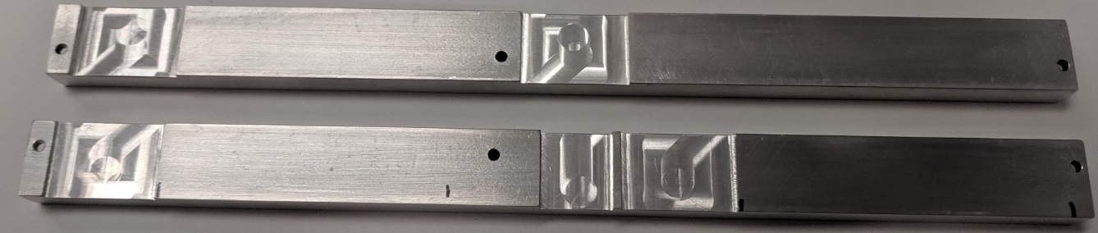

## 15) Attach the LGA80D heatsink

Cut 5 pieces of 70 mil pink thermal pad. Each piece should be about 3/8” square. Note: pieces this small are most easily cut by first peeling off the protective film from one side of the pad. Place one piece on top of the IC on each of the 5 LGA80D power supply modules.

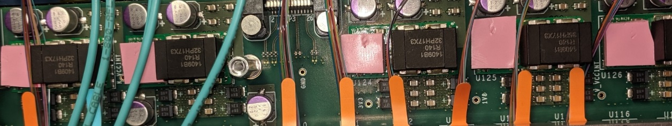

Place the LGA80D heatsink on top of the modules. Be sure to avoid catching any fiber optic wires. Use 3 M2.5x6 screws and 3 M2.5 lockwashers. In a staggered fashion, tighten them.

## 16) Route the KU15P FireFly cables

|  |  |  |  |  |  |
| --- | --- | --- | --- | --- | --- |
| Groove (top to bottom) | Source Quad | Direction  L-R or R-L | Has a loop | MTP Header |  |
| 1 | LMN xmit | Left to right | Loop |  |  |
| 2 | LMN recv | Left to right | Loop |  |  |
| 3 | P | Left to right | Loop |  |  |
| 4 | Q | Left to right | Loop |  |  |
| 5 | LMN xmit | Right to left | Loop | Top 1 |  |
| 6 | LMN recv | Right to left | Loop | Top 1 |  |
| 7 | P | Right to left | Loop | Bottom 1 |  |
| 8 | Q | Right to left | Loop | Bottom 2 |  |
| 9 | R | Left to right | Loop |  |  |
| 10 | OPEN |  |  |  |  |
| 11 | BCD xmit | Right to left |  | Top 2 |  |
| 12 | BCD recv | Right to left |  | Top2 |  |
| 13 | R | Right to left | Loop | Bottom 3 |  |
| 14 | EFG xmit | Right to left |  | Top 3 |  |
| 15 | EFG recv | Right to left |  | Top 3 |  |
| 16 | HIJ xmit | Right to left |  | Top 4 |  |
| 17 | HIJ recv | Right to left |  | Top4 |  |

Press the KU15P L/M/N XMIT cable into the #1 groove. Leave it off to the right.

Press the KU15P L/M/N RECV cable into the #2 groove. Leave it off to the right.

Press the KU15P P XCVR cable into the #3 groove. Leave it off to the right.

Press the KU15P Q XCVR cable into the #4 groove. Leave it off to the right.

Position the connector block #1 near the standoffs and plug the KU15P P XCVR cable into the first space.

From left to right, press the KU15P P XCVR cable into the #7 groove. There will be a turn-around loop on the right.

Plug the KU15P Q XCVR cable into the second space.

From left to right, press the KU15P Q XCVR cable into the #8 groove. There will be a turn-around loop on the right.

Press the KU15P R XCVR cable into the #9 groove. Leave it off to the right.

Plug the KU15P R XCVR cable into the third space.

From left to right, press the KU15P R XCVR cable into the #13 groove. There will be a turn-around loop on the right.

Using two M2.5x12 mm screws, attach connector block #1 to the standoffs.

Position the connector block #2 near the standoffs and plug the KU15P L/M/N cable into the first space.

From left to right, press the KU15P L/M/N XMIT cable into the #5 groove. This cable has a dark blue mark near the connector. There will be a turn-around loop on the right.

From left to right, press the KU15P L/M/N RECV cable into the #6 groove. The cable has no marking near the connector. There will be a turn-around loop on the right.

The next photo shows what has been done thus far. All of the front quads have been routed.

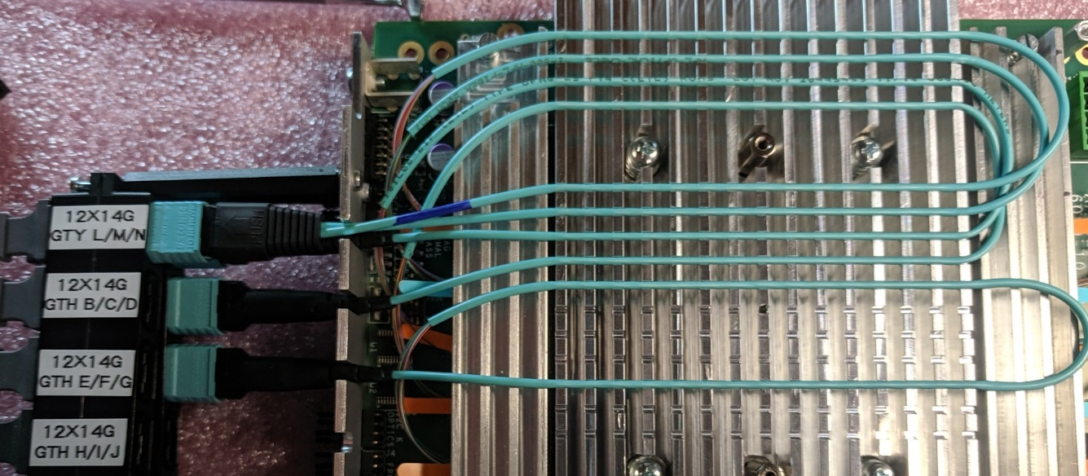

Plug the KU15P B/C/D cable into the second space of connector block #2.

From left to right, press the KU15P BCD XMIT cable into the #11 groove. This cable has a dark blue mark near the connector. There will be slack on the right.

From left to right, press the KU15P L/M/N RECV cable into the #12 groove. The cable has no marking near the connector. There will be slack on the right.

Plug the KU15P E/F/G cable into the third space of connector block #2.

From left to right, press the KU15P EFG XMIT cable into the #14 groove. This cable has a dark blue mark near the connector. There will be slack on the right.

From left to right, press the KU15P EFG RECV cable into the #15 groove. The cable has no marking near the connector. There will be slack on the right.

Plug the KU15P H/I/J cable into the fourth space of connector block #2.

From left to right, press the KU15P H/I/J XMIT cable into the #16 groove. This cable has a dark blue mark near the connector. There will be slack on the right.

From left to right, press the KU15P H/I/J RECV cable into the #17 groove. The cable has no marking near the connector. There will be slack on the right.

Using two M2.5x12 mm screws, attach connector block #2 to the standoffs.

The next photo shows what has been done thus far. All of the KU15P quads have been routed.

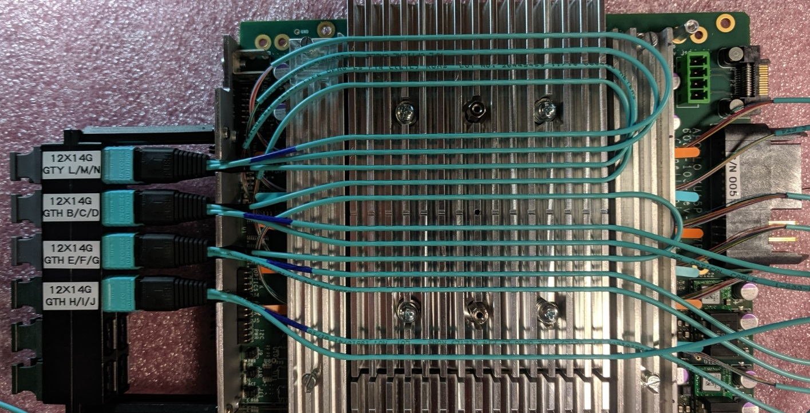

## 17) Route the VU7P FireFly cables

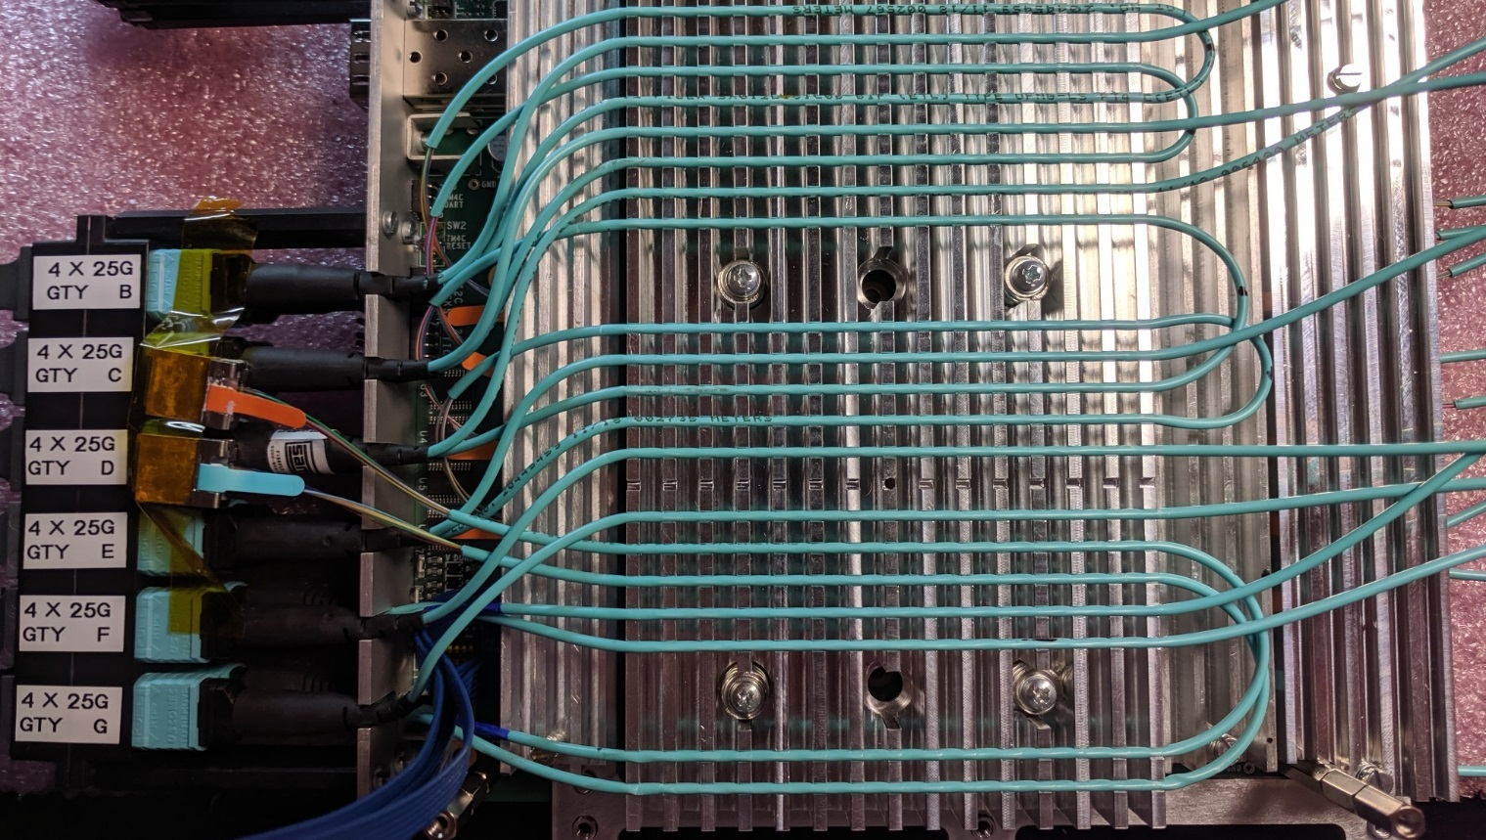

|  |  |  |  |  |  |
| --- | --- | --- | --- | --- | --- |
| Groove (top to bottom) | Source Quad | Direction  L-R or R-L | Has a loop | MTP Header |  |
| 3 | L | Left to right | Loop | Bottom 1 |  |
| 4 | B | Right to left |  | Top 1 |  |
| 5 | M | Left to right | Loop |  |  |
| 6 | L | Right to left | Loop |  |  |
| 7 | C | Right to left |  | Top 2 |  |
| 8 | M | Right to left | Loop | Bottom 2 |  |
| 9 | D | Right to left |  | Top 3 |  |
| 10 | N | Left to right | Loop |  |  |
| 11 | P | Left to right | Loop |  |  |
| 12 | E | Right to left |  | Top 4 |  |
| 13 | N | Right to left | Loop | Bottom 3 |  |
| 14 | P | Right to left | Loop | Bottom 4 |  |
| 15 | F | Right to left |  | Top 5 |  |
| 16 | OPEN |  |  |  |  |
| 17 | G | Right to left |  | Top 6 |  |
| 18 | QRS Xmit | Left to right | Loop |  |  |
| 19 | QRS Recv | Left to right | Loop |  |  |
| 20 | HIJ Xmit | Right to left |  | Bottom 5 |  |
| 21 | HIJ Recv | Right to left |  | Bottom 5 |  |
| 22 | QRS Xmit | Right to left | Loop | Bottom 6 |  |
| 23 | QRS Recv | Right to left | loop | Bottom 6 |  |

Position the connector block #3 near the standoffs.

Press the VU7P L XCVR cable into the #3 groove. Leave it off to the right.

Press the VU7P M XCVR cable into the #5 groove. Leave it off to the right.

Plug the VU7P L XCVR cable into the first space of connector block #3.

From left to right, press the VU7P L XCVR cable into the #6 groove. There will be a turn-around loop on the right.

Plug the VU7P M XCVR cable into the second space of connector block #3.

From left to right, press the VU7P M XCVR cable into the #8 groove. There will be a turn-around loop on the right.

Press the VU7P N XCVR cable into the #10 groove. Leave it off to the right.

Press the VU7P P XCVR cable into the #11 groove. Leave it off to the right.

Plug the VU7P N XCVR cable into the third space of connector block #3.

From left to right, press the VU7P N XCVR cable into the #13 groove. There will be a turn-around loop on the right.

Plug the VU7P P XCVR cable into the fourth space of connector block #3.

From left to right, press the VU7P P XCVR cable into the #14 groove. There will be a turn-around loop on the right.

Plug the VU7P Q/R/S cable into the sixth space of connector block #3.

From left to right, press the VU7P Q/R/S XMIT cable into the #18 groove. This cable has a dark blue mark near the connector. Leave it off to the right.

From left to right, press the VU7P Q/R/S RECV cable into the #19 groove. The cable has no marking near the connector. Leave it off to the right.

From left to right, press the VU7P Q/R/S XMIT cable into the #22 groove. This cable has a dark blue mark near the connector. Leave it off to the right.

From left to right, press the VU7P Q/R/S RECV cable into the #23 groove. The cable has no marking near the connector. Leave it off to the right.

Plug the VU7P H/I/J cable into the fifth space of connector block #3.

From left to right, press the VU7P H/I/J XMIT cable into the #20 groove. This cable has a dark blue mark near the connector. There will be slack on the right.

From left to right, press the VU7P H/I/J RECV cable into the #21 groove. The cable has no marking near the connector. There will be slack on the right.

Using two M2.5x12 mm screws, attach connector block #3 to the standoffs.

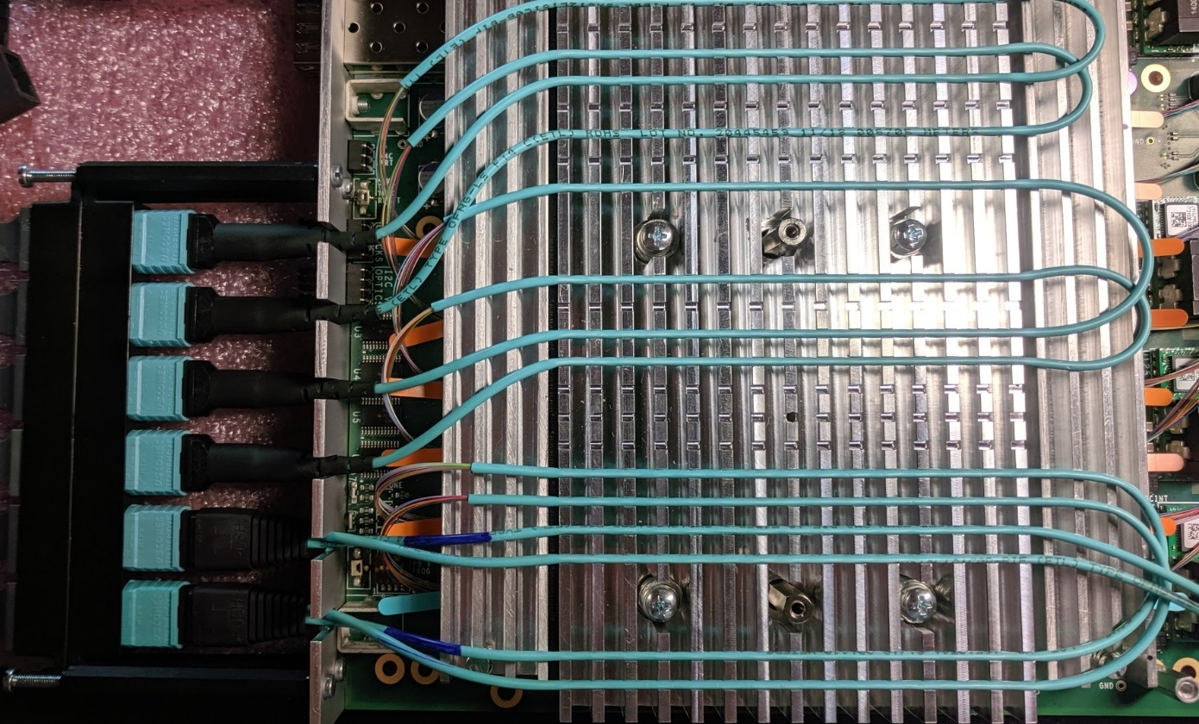

Plug the VU7P B XCVR cable into the first space of connector block #4.

From left to right, press the VU7P B XCVR cable into the #4 groove. There will be a slack on the right.

Plug the VU7P C XCVR cable into the second space of connector block #4.

From left to right, press the VU7P C XCVR cable into the #7 groove. There will be a slack on the right.

Plug the VU7P D XCVR cable into the third space of connector block #4.

From left to right, press the VU7P D XCVR cable into the #9 groove. There will be a slack on the right.

Plug the VU7P E XCVR cable into the fourth space of connector block #4.

From left to right, press the VU7P E XCVR cable into the #12 groove. There will be a slack on the right.

Plug the VU7P F XCVR cable into the fifth space of connector block #4.

From left to right, press the VU7P F XCVR cable into the #15 groove. There will be a slack on the right.

Plug the VU7P G XCVR cable into the sixth space of connector block #4.

From left to right, press the VU7P G XCVR cable into the #17 groove. There will be a slack on the right.

Using two M2.5x12 mm screws, attach connector block #4 to the standoffs.

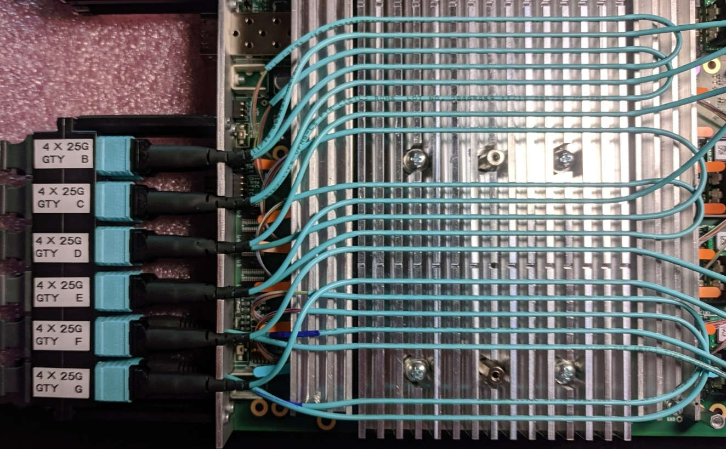

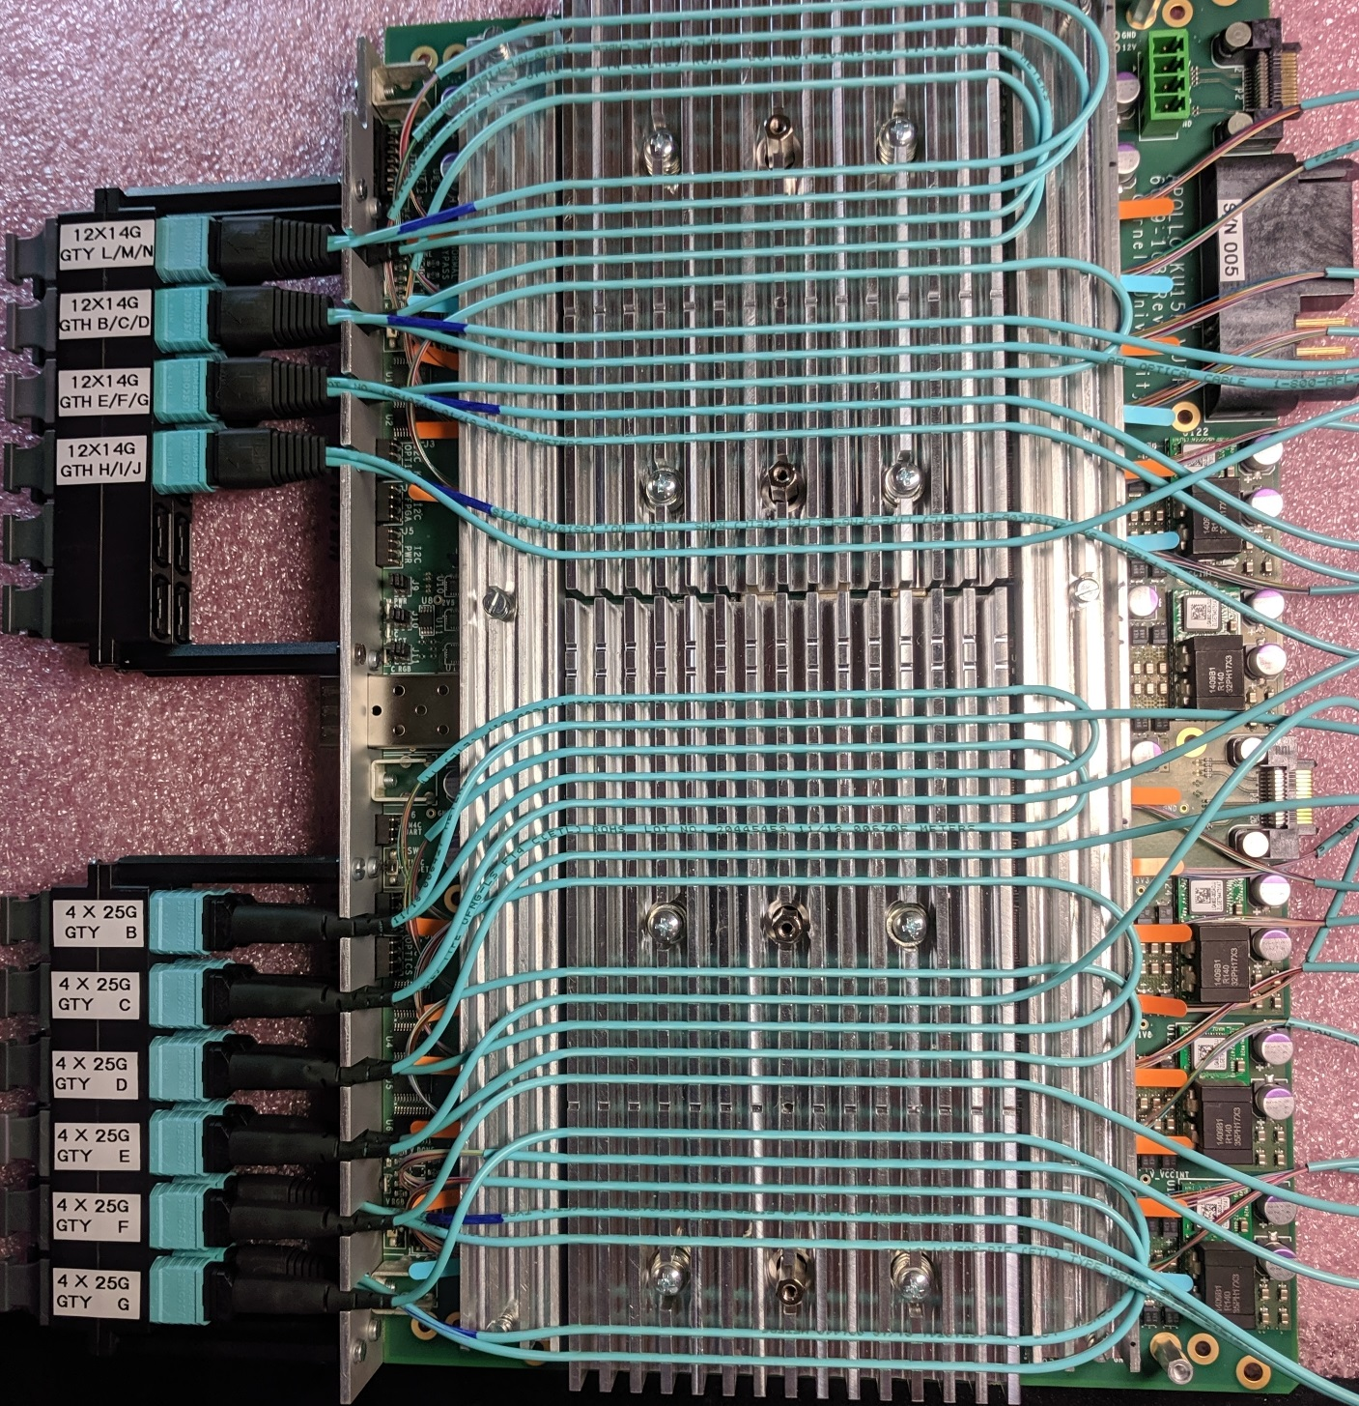

## 17) Mate the CM to the SM

## 18) Install the small Front Panel Board

## 19) Attach the covers

# ADDING AN IND045 M3V3 DC-DC CONVERTER

Four boards had the original M3V3 regulator removed due to mounting difficulties. The new regulator is an IND045. It is mounted “dead bug” style near the big power connector. A piece of “sticky square” holds it to the board.

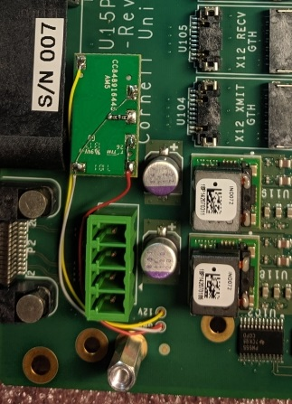 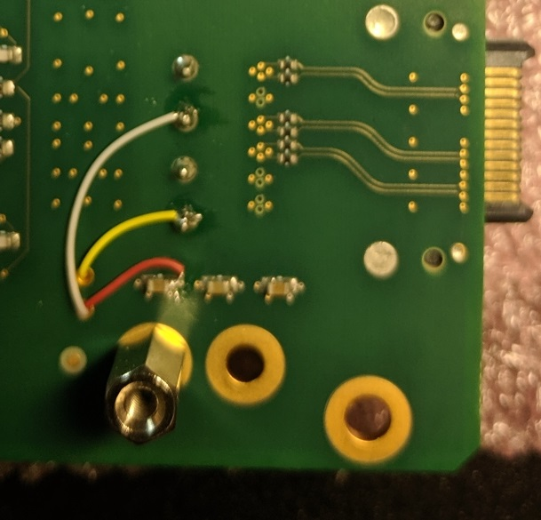

The wire colors are :

Yellow = +12

White = GND

Red = M3V3

The “sense” resistors are a pair of 13.3k resistors in series.

# DRIVING I2C SLAVES FROM THE AARDVARK HOST ADAPTER

Any of the six I2C chains can be driven from an external host adapter. The host adapter is connected by removing the 4 jumpers from the desired I2C chain and attaching the Aardvark I2C/SPI adapter by way of a custom cable, then running the TotalPhase SerialControl program.

The manual is at:

https://www.totalphase.com/support/articles/200468316-Aardvark-I2C-SPI-Host-Adapter-User-Manual

1) Remove the jumpers from the desired I2C slave bus. In this case, it is the I2C bus for the DC-DC converters.

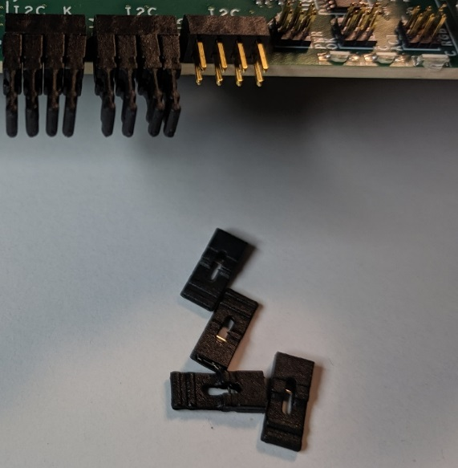

2) Attach the adapter cable that is labeled “BOARD IS SLAVE”. The wires connect to the top row of pins, with the yellow wire to the left and the white wire to the right. The 8-pin front panel connector is not keyed. The 10-pin connector to the adapter is keyed.

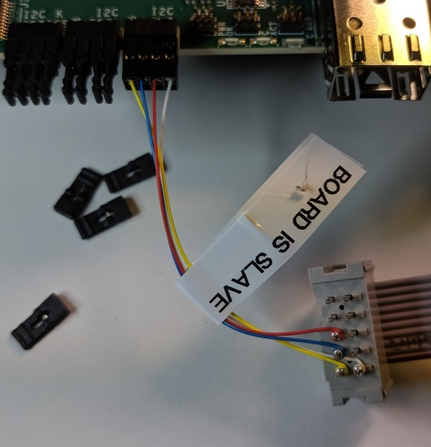

3) The signals are:

Yellow = SCL (I2C Clock)

Blue = SDA (I2C Data)

Red = RESET

White = GND

4) Start the TotalPhase “Control Center Serial” program. From the menu bar, select “Adapter” Then scroll down to “I2C + GPIO”.

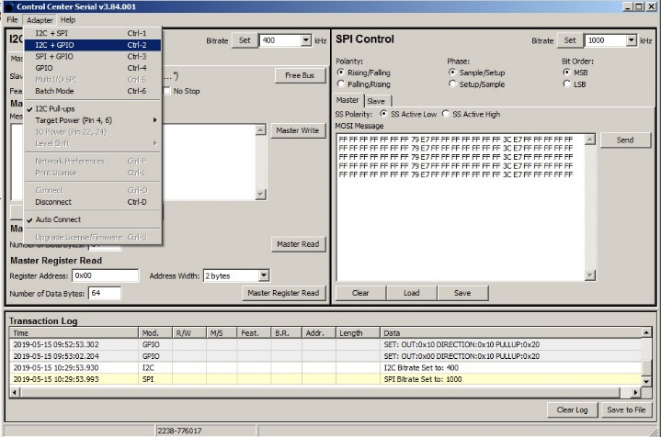

5) The right side of the screen will change from “SPI Control” to “GPIO Control”. GPIO #2 drives the active-low “reset” signal. It needs to be high for normal operation. Select the direction for GPIO #2 to be “Out”, set the “Out Set” value to be “1’”, and press the “Set” button.

Anytime you want to perform a reset operation, set the “Out Set” value to “0” and press the “Set” button. Then set the “Out Set” value to be “1’”, and press the “Set” button again.

GPIO #2 to “Out”

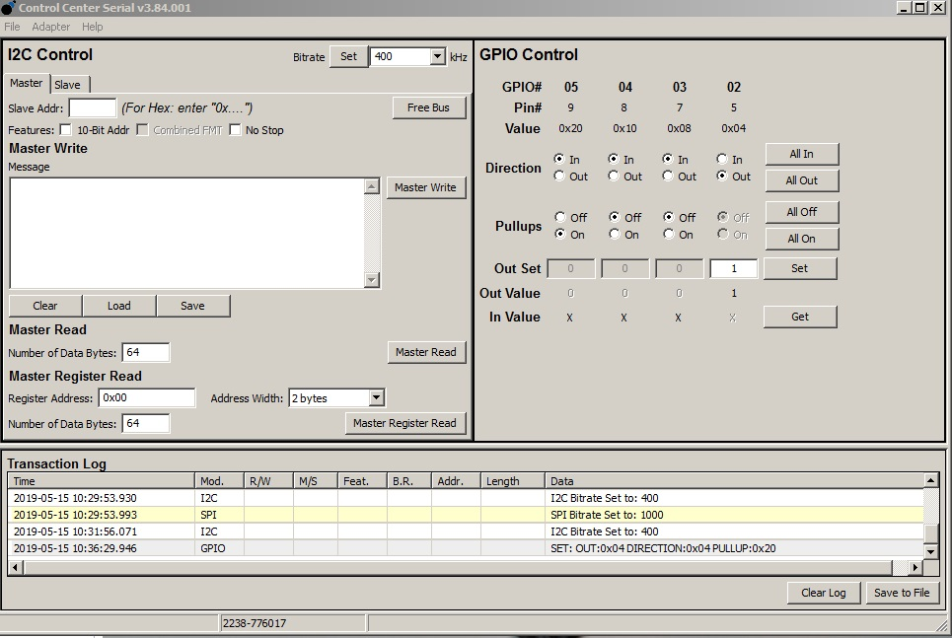

Press to activate

“Out” to 1

6) To configure a TCA9548A bus switch, set the “Bitrate” to “100 kHz”, set the “Slave Addr” to 0x70, and the “Master Write” message to the hex data representing the switch bits to set. Press the “Master Write” button. Read it back by setting the “Master Read” number of data bytes to 1 and pressing the “Master Read” button. The results show in the “Transaction Log” window.

Bitrate to 100 kHz

Write message to 1

Slave Addr to 0x70

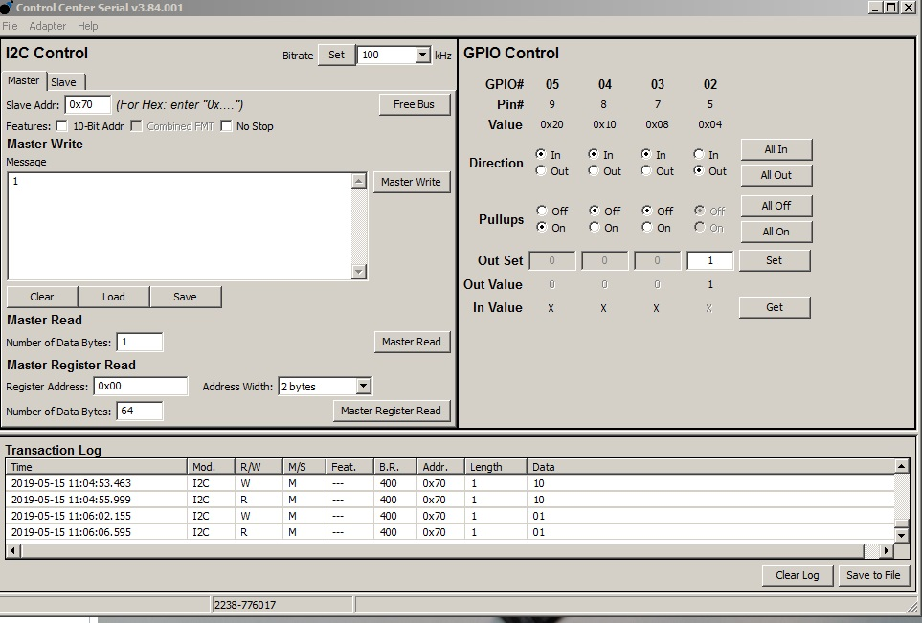

Result of read

Read bytes to 1

# OBSERVING I2C MASTERS WITH THE AARDVARK HOST ADAPTER

Any of the six I2C chains can be substituted with the external host adapter. The host adapter is connected by removing the 4 jumpers from the desired I2C chain and attaching the Aardvark I2C/SPI adapter by way of a custom cable, then running the TotalPhase SerialControl program.

1) Remove the jumpers from the desired I2C slave bus. In this case, it is the I2C bus for the DC-DC converters.



2) Attach the adapter cable that is labeled “BOARD IS MASTER”. The wires connect to the bottom row of pins, with the yellow wire to the left and the white wire to the right. The 8-pin front panel connector is not keyed. The 10-pin connector to the adapter is keyed.

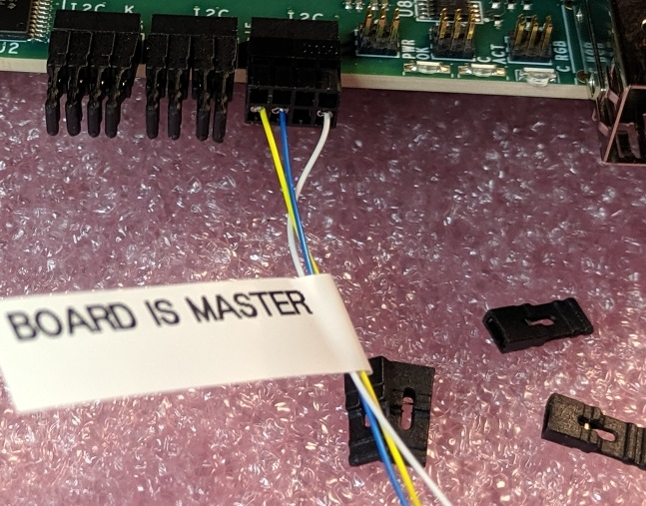

3) The signals are:

Yellow = SCL (I2C Clock)

Blue = SDA (I2C Data)

Red = RESET (omitted initially until all TM4C I2C reset pins are open drain)

White = GND

# HISTORY LOG

This section of the manual contains a log of the history for each board, according to the serial number.

## S/N 001

This is one of the three first build prototypes.

1. The initial modifications described in the “problems” section of the 6089-103_checkout.docx document were performed.

Mod 3: Installed proper size capacitors

Mod 4:Resistors removed

Mod 5: GND jumpers added

Mod 6: Load resistors will not be added to prototype boards, except S/N 002

Mod 7: Resistors either removed or changed

Mod 11: LED resistors were changed

Mod 12: LGA80D resistors were changed

2. The KU15P MGTH_AVCC regulator, U118, did not work. It would click and put out voltage pulses. The output capacitors were removed, to no avail. It was sent back to MPL to be replaced and now it is fine, but the adjacent U119 regulator is now clicking and does not normally work. However, if I put pressure with my finger, it can be made to work. It sounds like the rework disturbed the adjacent part. MPL has been contacted for analysis.

3. MPL dissected regulator U119 and did not find any problem. They removed the module by pulling on it as it was heated. This would result in “peaks” in the solder joints that were good, and rounded tops in any solder joints that had not been connected. They reported that all of the solder joints to the board looked good. They installed a new regulator, and it tests OK.

4. MPL attached a VU7P. The KU15P site was left empty. All power supplies came up OK. The KU15P supplies were disabled via position 4 of DIP SWITCH SW4.

5. The board was prepped with 10 25G x 4 FireFly modules.

6. The VU7P MGTY2_AVCC regulator failed(U120). The board was stripped down (all heatsinks and FireFlys). MPL replaced it. The board was reassembled and is ready for test.

7. Another VU7P IND072 regulator failed. This one runs for a while and then shuts down. Diagnostics have not been done yet. It is the VU7P MGTY1_AVCC (U17).

8. The power to the I2C pullups and buffer for the PWR leg have been modified so that they run from the management power VCC_M3V3.

a. Lift the powered side of the following resistors and wire them to VCC_M3V3.

R395 R398 R388 R391 R380 R385 R341 R345 R401 R404  
R689 R690  
R691

1. Lift pin-24 of U91 and wire it to VCC_M3V3

9. 05Aug2020 – The board was stripped down and sent to MPL to replace the IND072 (U17) which failed hard.

## S/N 002

This is one of the three first build prototypes.

1. The initial modifications described in the “problems” section of the 6089-103_checkout.docx document were performed.

Mod 3: Installed proper size capacitors

Mod 4: Resistors removed

Mod 5: GND jumpers added

Mod 6: Load resistors were added to only this board

Mod 7: Resistors either removed or changed

Mod 11: LED resistors were changed

Mod 12: LGA80D resistors were changed

2. The socket for the KU15P was installed, and a KU15P was inserted.

3.The socket for the VU7P was installed. However, no FPGA was inserted, so this board has an empty socket.

4. The full complement of KU15P FireFly devices was installed.

5. 05Aug2020 – The board was stripped down and sent to MPL to have a “-2” version of the VU7P attached.

## S/N 003

This is one of the three first build prototypes.

1. The initial modifications described in the “problems” section of the 6089-103_checkout.docx document were performed.

Mod 3: Installed proper size capacitors

Mod 4: Resistors removed

Mod 5: GND jumpers added

Mod 6: Load resistors will not be added to prototype boards, except S/N 002

Mod 7: Resistors either removed or changed

Mod 11: LED resistors were changed

Mod 12: LGA80D resistors were changed

## GENERAL HISTORY

Seven more boards were assembled (S/N 004 through S/N 010). The BOM had been modified so that that only remaining modification from the initial mods was Mod 5 (adding GND jumpers).

A problem was discovered with the M3V3 regulator U31. It was not properly soldered on 4 of the 7 boards. Rather than fix it, a decision was made to replace it with an IND045. The four boards were sent to MPL to have U31 and the voltage setting resistors removed. The IND045 was added at Cornell.

## S/N 004

This is one of the seven second build prototypes.

1. The remaining initial modification described in the “problems” section of the 6089-103_checkout.docx document was performed.

Mod 5: GND jumpers added

2. The socket for the KU15P was installed, and a KU15P was inserted.

3. The socket for the VU7P was installed, and a VU7P was inserted.

4. This board was mated to the SM and set up for testing at the PSB. It does not have any FireFly modules.

5. 05Aug2020 – The board was stripped down and sent to MPL to have a “-2” version of the VU7P attached, as well as a KU15P.

## S/N 005

This is one of the seven second build prototypes.

1. The remaining initial modification described in the “problems” section of the 6089-103_checkout.docx document was performed.

Mod 5: GND jumpers added

2. The board was sent to MPL to have both a KU15P and a VU7P soldered.

3. All FireFly modules for both FPGAs were installed.

4. This board was set up in the PSB with fiber optic cables and loopbacks so that Ed from Rutgers could test them.

5. Ed’s initial report was that a set of links did not work after first loading the bit file, but worked fine after reloading the bit file. This sounds like some type of initialization problem, and not a board/hardware problem.

6. The board was sent to BU with all FireFlys, along with a 12-fiber and a 24-fiber cable.

09 Oct 2019

7. The board was returned from BU. Three 12x14G modules with long cables were removed (KU15P L/M/N, VU7P H/I/J, and VU7P Q/R/S). A 12x14G module with a short cable was installed (VU7P Q/R/S).

8. Proper standoffs and block were installed for the covers, along with water-jet cut covers (delaminated around holes)

9. The FireFly thermal pad was upgraded.

10. The LGA80D heatsink was installed.

11. The board was shipped back to BU.

## S/N 006

This is one of the seven second build prototypes.

1. The remaining initial modification described in the “problems” section of the 6089-103_checkout.docx document was performed.

Mod 5: GND jumpers added

2. When power was applied, the board exhibited a dead short from +12 to GND, drawing significant current. This was assumed to be related to the U31 mounting problem, so the board was sent to MPL to have U31 and its resistors removed.

3. The IND045 for M3V3 was added and tests OK

4. The MCU was programmed with “project2_27Aug19.bin”. Upon power-up, the KU15P supplies were all OK. The VU7P supply U121 (MGTY2_AVTT) does not put out any voltage. An NG tag was put on it.

This may be good for a KU15P.

## S/N 007

This is one of the seven second build prototypes.

1. The remaining initial modification described in the “problems” section of the 6089-103_checkout.docx document was performed.

Mod 5: GND jumpers added

2. When power was applied, the board did not generate any voltage on M3V3. This was assumed to be related to the U31 mounting problem, so the board was sent to MPL to have U31 and its resistors removed.

3. The IND045 for M3V3 was added and tests OK.

4. The MCU was programmed with “project2_27Aug19.bin”. Upon power-up, the KU15P supplies were all OK and the VU7P power supplies were all OK.

15Oct 2019

5. The MCU was programmed with “project2_v0_9.bin”. Eight fireflys were installed on the VU7P, none on the KU15P. Final assembly was done to get this board ready to go to CERN.

6. The board was sent to CERN. It was at the TIF, however power supply U120 was failing. It was returned to Cornell.

7. 05Aug2020 – The board was stripped down and sent to MPL to replace the IND072 (U120) which failed hard.

## S/N 008

This is one of the seven second build prototypes.

1. The remaining initial modification described in the “problems” section of the 6089-103_checkout.docx document was performed.

Mod 5: GND jumpers added

2. When power was applied, the voltage on M3V3 tracked the input voltage on +12v I think it only went up to about 4.5 volts, but there may be non-apparent chip damage. This was assumed to be related to the U31 mounting problem, so the board was sent to MPL to have U31 and its resistors removed.

3. The IND045 for M3V3 was added and tests OK.

4. The MCU was programmed with “project2_27Aug19.bin”. Upon power-up, the KU15P supplies were all OK and the VU7P power supplies were all OK.

5. Both FPGAs have been soldered

6. The power to the I2C pullups and buffer for the PWR leg have been modified so that they run from the management power VCC_M3V3.

a. Lift the powered side of the following resistors and wire them to VCC_M3V3.

R395 R398 R388 R391 R380 R385 R341 R345 R401 R404  
R689 R690  
R691

1. Lift pin-24 of U91 and wire it to VCC_M3V3

## S/N 009

This is one of the seven second build prototypes.

1. The remaining initial modification described in the “problems” section of the 6089-103_checkout.docx document was performed.

Mod 5: GND jumpers added

2. When power was applied, the voltage on M3V3 was fine, so the U31 regulator was left unchanged.

3. The MCU was programmed with “project2_27Aug19.bin”. Upon power-up, the KU15P supplies were all OK and the VU7P power supplies were all OK.

This board is ready for both FPGAs

## S/N 010

This is one of the seven second build prototypes.

1. The remaining initial modification described in the “problems” section of the 6089-103_checkout.docx document was performed.

Mod 5: GND jumpers added

2. When power was applied, the board did not generate any voltage on M3V3. This was assumed to be related to the U31 mounting problem, so the board was sent to MPL to have U31 and its resistors removed.

3. The IND045 for M3V3 was added and tests OK

4. The MCU was programmed with “project2_27Aug19.bin”. Upon power-up, the KU15P supplies were all OK and the VU7P power supplies were all OK.

5. Both FPGAs have been soldered.